Date of publication xxxx 00, 0000, date of current version xxxx 00, 0000.
Digital Object Identifier 10.1109/ACCESS.2024.Doi Number

Preparation of Papers for IEEE Access
(April 2024)

K.NISHMITHA^{A}, AMMANA ADITI REDDY^{A}, AENUGU PRACHETHA REDDY^{A}, K.SWAPNIKA^{A}
^{A}Department of Computer Science and Engineering, Koneru Lakshmaiah Education Foundation, Bowrampet, Hyderabad-500043, Telangana, India.
email-id: 2420030525@klh.edu.in
This paragraph of the first footnote will contain support information, including sponsor and financial support acknowledgment. For example,
“This work was supported in part by the U.S. Department of Commerce under Grant BS123456.”

ABSTRACT
This paper presents a Business Intelligence (BI) framework for organizational performance analysis using the Superstore Sales Dataset. The study addresses the difficulty of converting transaction-level business records into concise information that can support analysis of sales, profitability, customers, products, regions, and time-based performance. The proposed workflow combines data-quality assessment, preprocessing, exploratory data analysis (EDA), KPI formulation, analytical modelling, and interactive visualization. The dataset contains 9,994 transaction records and 21 attributes, with 5,009 distinct orders, 793 customers, and 1,862 product identifiers. The dataset contains no missing values and no duplicate rows in the supplied file. Descriptive analysis shows total sales of 2,297,200.86, total profit of 286,397.02, a profit margin of 12.47%, and an average order value of 458.61. West records the highest regional sales, Technology has the highest category sales and profit, and Consumer is the largest customer segment by sales. Correlation analysis indicates a positive association between sales and profit and a negative association between discount and profit. The study proposes Power BI as the presentation and decision-support layer, with Python/Pandas used for analytical preparation and validation. The contribution is a structured KPI-to-dashboard workflow that connects data quality, EDA, business performance measures, and interactive visual analysis. Because the Power BI front-end is still to be finalized, dashboard screenshots and interface-level usability measurements are identified as implementation evidence to be inserted after dashboard completion.
1. INTRODUCTION
1.1 Background
[Organizations generate large volumes of transactional data through sales, customer interactions, products, orders, and regional operations. Business Intelligence provides a systematic way to convert such data into information that can support managerial analysis and decision-making. Prior research describes BI as a combination of data integration, analytical processing, reporting, visualization, and decision-support capabilities [1]–[8]. Modern BI&A research also emphasizes the progression from traditional reporting toward analytics, visualization, and more interactive forms of decision support [5], [6].
In organizational performance analysis, raw tables alone make it difficult to identify patterns across several dimensions simultaneously. For example, a manager may need to know whether a region has high sales but comparatively low profit, which product categories generate the largest contribution, how customer segments differ, and whether discounting is associated with lower profitability. Interactive visualization can reduce the effort required to explore such relationships, although the effectiveness of visualization depends on task, design, interaction, and user characteristics [11], [14]–[19].

1.2 Problem Statement
The core problem addressed in this study is the conversion of transaction-level sales data into an organized analytical view of organizational performance. Traditional static tables or isolated calculations require users to repeatedly filter, aggregate, and compare data. The research therefore investigates how a structured BI workflow combining preprocessing, EDA, KPI analysis, and interactive dashboard design can provide a consolidated view of organizational performance.
1.3 Research Gap
Existing BI literature establishes the value of data quality, integrated information, analytical capabilities, and decision-support systems [1]–[10]. Visualization research further demonstrates that interaction, task alignment, and visual encoding influence how users interpret information [11], [14]–[19]. However, the literature contains relatively fewer student-scale implementations that explicitly connect a complete transaction-level data preparation workflow to KPI-driven organizational analysis and an interactive dashboard in one reproducible pipeline. This study addresses that implementation-oriented gap by combining Python-based analytical preparation and validation with a Power BI presentation layer, while explicitly documenting data quality, EDA, KPI formulation, system architecture, and evaluation criteria.
1.4 Research Objective
- Design an end-to-end Business Intelligence workflow for organizational performance analysis using the Superstore Sales Dataset.
- Perform data-quality assessment, preprocessing, descriptive analysis, EDA, correlation analysis, and time-based analysis.
- Develop business KPIs covering sales, profit, orders, profit margin, average order value, regional performance, category performance, product performance, and customer segments.
- Design an interactive Power BI dashboard architecture that supports filtering, drill-down, comparison, and decision-oriented interpretation.
- Evaluate the analytical coverage and compare the proposed workflow with conventional static reporting and Python-only descriptive analysis approaches without fabricating unsupported performance claims.
1.5 Research Questions
- RQ1: What organizational performance patterns can be identified from the Superstore Sales Dataset through systematic BI-oriented EDA and KPI analysis?
- RQ2: ow can the combination of data preparation, KPI modeling, and interactive visualization support multi-dimensional business performance analysis?
- RQ3: How does the proposed BI workflow differ in analytical coverage and interactivity from conventional static reporting and standalone descriptive analysis?
- RQ4: What practical insights can be derived for sales, profitability, customers, products, regions, and time-based performance?
1.6 Contributions
- [ Contribution 1 —A reproducible end-to-end BI workflow connecting data quality assessment, EDA, KPI development, dashboard modeling, and decision-support presentation.]
- [ Contribution 2 —A structured KPI framework covering sales, profit, orders, margin, average order value, region, category, product, and customer segment performance. ]
- [ Contribution 3 —An evidence-based experimental analysis of the supplied Superstore dataset, including data-quality results, descriptive statistics, correlations, regional/category/segment comparisons, and time-based trends.]
- [ Contribution 4 —A practical dashboard architecture that connects Python/Pandas analytical validation with Power BI interactive visualization.]
1.7 Organization of the Paper
Section 2 reviews related BI, analytics, data warehousing, visualization, and dashboard literature. Section 3 presents the proposed methodology, dataset, preprocessing, EDA, analytical baselines, and mathematical formulation. Section 4 describes the experimental setup and evaluation strategy. Section 5 reports the empirical results obtained from the supplied dataset. Section 6 discusses the findings and their implications. Section 7 presents limitations. Section 8 concludes the paper and describes future work, followed by declarations and references.
2. RELATED WORK
2.1 Existing Approaches
[Foundational BI work frames BI as the combination of operational data, analytical tools, data warehousing, cleansing, reporting, and decision support [1], [2], [8]. Jourdan et al. reviewed 167 BI-related articles and highlighted the breadth of BI research and the need for further empirical investigation [3]. Baars and Kemper proposed an integrated BI framework that connects data sources and management-support components [4]. Chen et al. described BI&A as an evolving field spanning traditional BI, web-based analytics, and advanced analytics [5]. Research on BI success further identifies data quality, user access, system integration, organizational context, and decision environment as important factors [7].]
2.2 Machine Learning / Computational Approaches
Modern analytics research increasingly connects BI with computational approaches including data mining, predictive analytics, and big-data analytics [6], [9], [27], [28]. Lim et al. categorized BI&A research into major analytical directions and identified opportunities for advanced analytics [6]. Wamba et al. empirically linked big-data analytics capabilities with firm performance through a model involving dynamic capabilities [27]. Mikalef et al. similarly examined how organizations translate analytics capabilities into business value [28]. In the present project, machine learning is not treated as a required component of the current implementation; instead, the computational focus is on reproducible descriptive analytics and KPI-based BI, while predictive modeling remains future scope.
2.3 Advanced / Alternative Approaches
[Alternative approaches include data warehousing, OLAP-style reporting, visual analytics, and interactive information visualization. Watson and Wixom describe BI as involving both the movement of data into integrated repositories and the subsequent use of that data for reporting and analysis [2]. Thomas and Cook emphasize visual analytics as a combination of analytical reasoning, visual representation, interaction, and data transformation [20]. Interactive visualization research further shows that filtering, linking, and dynamic view manipulation can support iterative exploration [15], [16].
]
2.4 Explainability / Interpretability (or other relevant sub-theme)
[Interpretability is important in BI because business users need to understand not only a numerical result but also the dimensions and conditions that produced it. Visualization research emphasizes task-oriented design, visual encoding, interaction, and validation [14]–[19]. Recent dashboard research also points to the importance of dashboard content and cognitive load in BI adoption [12]. The proposed project therefore emphasizes transparent KPI definitions, visible filters, grouped comparisons, and drill-down-oriented interpretation rather than opaque predictive models.]
2.5 Critical Comparison
Table 1 summarizes representative studies from the literature, highlighting their key contributions and limitations.

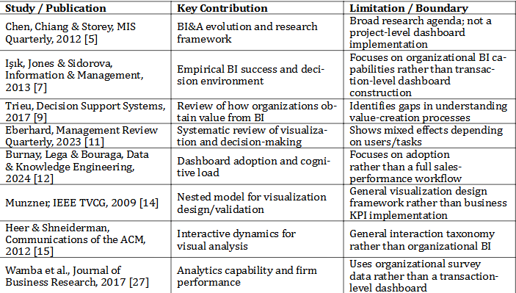
Table 1. [ Caption summarizing what this comparison table shows. ]

2.6 Research Gap (Summary)
[The reviewed literature establishes the importance of BI capabilities, data quality, analytics, visualization, and interactive decision support [1]–[12], [14]–[20]. At the same time, the literature spans broad organizational frameworks, visualization theory, and analytics-capability studies. The present work focuses on a reproducible, implementation-oriented pipeline that begins with a real transaction dataset and proceeds through data-quality assessment, EDA, KPI construction, comparative business analysis, and dashboard design. The proposed contribution is therefore not a new visualization algorithm; it is the structured integration and documentation of these analytical stages for organizational performance analysis.]
3. PROPOSED METHODOLOGY
3.1 Overall Framework
[The proposed framework follows a sequential but iterative pipeline: dataset acquisition, data-quality assessment, preprocessing, exploratory analysis, KPI development, analytical modeling, dashboard design, evaluation, and decision-support interpretation. Each stage produces an output used by the next stage. The workflow is designed to keep business definitions visible and reproducible. ]

[ Figure 1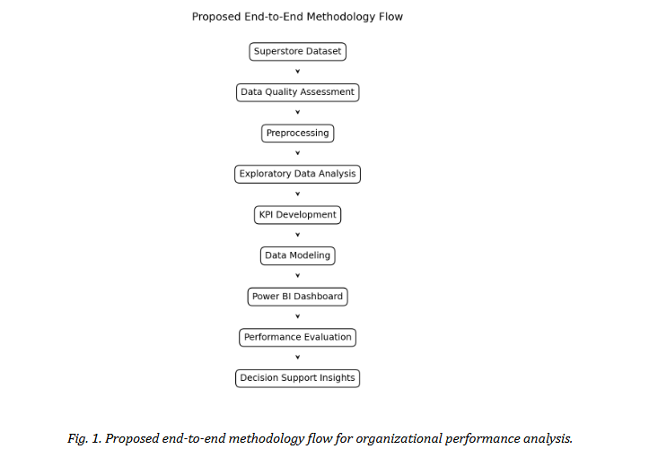 — Overall framework / pipeline diagram ]
3.2 Dataset(s)
[The experimental dataset is the supplied Superstore Sales Dataset. It contains 9,994 records and 21 attributes covering orders, customers, products, geography, sales, quantity, discount, and profit. The order-date range is 3 January 2014 to 30 December 2017. The dataset contains 5,009 distinct orders, 793 distinct customers, 1,862 distinct product identifiers, 4 regions, 3 categories, 3 customer segments, 17 sub-categories, 49 states, 531 cities, and one country represented in the supplied file. The dataset was selected because it contains multiple business dimensions required for organizational performance analysis.. ]
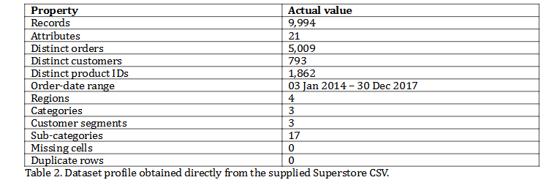
3.3 Data Preprocessing
[ Data preprocessing begins with structural inspection and data-quality checks. The supplied file contains no missing cells and no exact duplicate rows, so deletion or imputation of records was not required for these two issues. Date fields are parsed as dates for time-based analysis. Numerical variables are retained as numeric values. Categorical attributes such as Region, Category, Sub-Category, Segment, and Ship Mode are retained as categorical dimensions. Potential outliers are screened using the 1.5×IQR rule, but they are not automatically deleted because extreme sales and profit values may represent legitimate business transactions. The observed IQR screening counts are 1,167 for Sales, 1,881 for Profit, 170 for Quantity, and 856 for Discount. These observations are treated as analytical flags rather than automatic errors.
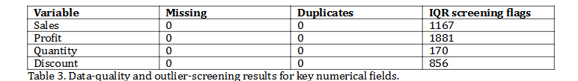
3.4 [ Exploratory Analysis / Feature Engineering, as relevant ]
EDA is organized into univariate, bivariate, multivariate, correlation, and temporal analysis. Univariate analysis examines distributions and descriptive statistics. Bivariate analysis evaluates relationships such as Sales–Profit and Discount–Profit. Multivariate analysis groups performance by Region, Category, Segment, and time. Feature engineering is intentionally lightweight: Profit Margin is calculated from total profit divided by total sales, Average Order Value is calculated from total sales divided by distinct orders, and year/month fields are derived from Order Date for time-based aggregation.

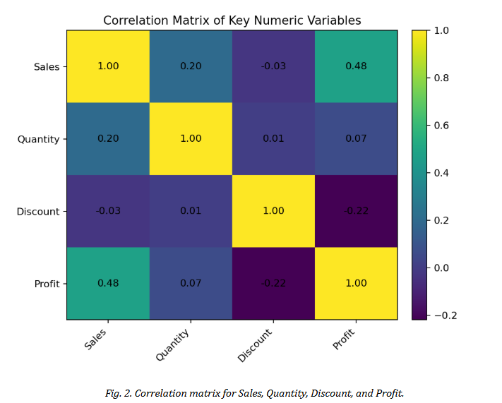
3.5 Proposed Model(s) and Baselines
The project is a BI/visual analytics study rather than a supervised machine-learning classification or regression study. Therefore, conventional ML metrics such as accuracy, precision, recall, or F1-score are not appropriate for the primary experiment. Instead, the study compares three analytical approaches on capability and evidence: (A) static/tabular reporting, (B) Python-based descriptive analysis, and (C) the proposed Python-validated plus Power BI interactive BI workflow. Approach C is intended to preserve the reproducibility of numerical analysis while adding interactive filtering and dashboard-level decision support.
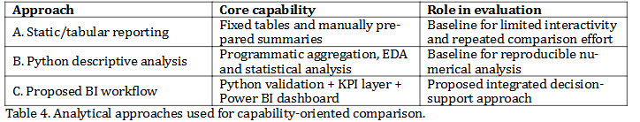
3.6 Algorithmic / Mathematical Formulation
The core KPIs are defined as follows.
Total Sales = Σ Salesᵢ
Total Profit = Σ Profitᵢ
Profit Margin (%) = (Total Profit / Total Sales) × 100
Total Orders = number of distinct Order IDs
Average Order Value = Total Sales / Total Orders
For correlation analysis, Pearson's correlation coefficient r is used to quantify linear association between two numerical variables:
r = Σ[(xᵢ − x̄)(yᵢ − ȳ)] / √(Σ(xᵢ − x̄)² Σ(yᵢ − ȳ)²)
These definitions are transparent and directly reproducible from the supplied dataset.

4. EXPERIMENTAL SETUP
4.1 Hardware and Software
[The analytical environment uses Python with Pandas and NumPy for data manipulation, Matplotlib and Seaborn for visualization, and Microsoft Power BI/Power Query/DAX for the dashboard stage. The work is designed for a standard student laptop/desktop capable of running Python and Power BI Desktop. Exact hardware specifications are not required for the descriptive analysis because no computationally intensive ML model is trained.]
4.2 Dataset Split / Design
[No train/test split is required for the primary descriptive BI experiment because the objective is organizational performance analysis rather than predictive model training. The complete supplied dataset is analyzed descriptively. Temporal grouping is used to examine yearly and monthly trends. Any future predictive extension would require a time-aware train/test design and should not be retroactively claimed for the present study.]
4.3 Hyperparameter Configuration
[Hyperparameter tuning is not applicable to the current descriptive BI implementation because no machine-learning model is used as the primary analytical method. The analytical configuration instead consists of fixed KPI definitions, grouping dimensions, correlation analysis, and visualization rules. Power BI visual configurations such as slicers, drill-down hierarchies, and chart selections will be documented after the dashboard is implemented. ]
4.4 Validation Strategy
[Validation is based on deterministic cross-checking of aggregate values. Total Sales, Total Profit, distinct Orders, and grouped Region/Category/Segment totals are computed directly from the CSV using Pandas. These values form the reference values against which corresponding Power BI measures should be checked. This procedure validates numerical consistency without claiming model accuracy.]
4.5 Evaluation Metrics
- Data completeness: proportion of non-missing cells.
- Duplicate rate: duplicate records divided by total records.
- Analytical coverage: number of organizational dimensions and KPI families represented.
- Correlation strength: Pearson's r for selected numerical relationships.
- Business KPI values: Total Sales, Total Profit, Profit Margin, Total Orders, and Average Order Value.
- Capability comparison: presence/absence of filtering, drill-down, interactive cross-analysis, KPI cards, and dashboard-level synthesis.

4.6 Statistical Testing
[Pearson correlation tests are used only as exploratory statistical evidence for relationships among numerical variables. For the supplied data, Sales and Profit show a positive correlation (r = 0.479, p < 0.001), Discount and Profit show a negative correlation (r = −0.219, p < 0.001), Sales and Quantity show a positive correlation (r = 0.201, p < 0.001), and Quantity and Profit show a weak positive correlation (r = 0.066, p < 0.001). Because the dataset is a benchmark transaction dataset rather than a random sample from a defined population, statistical significance should not be interpreted as causal evidence.]
5. RESULTS
[The following are confirmed empirical results calculated from the supplied Superstore CSV. They represent dataset-level analytical findings. Power BI front-end output screenshots are intentionally marked for insertion after the dashboard is completed; no screenshot is fabricated.]
5.1 Overall Performance
[The dataset contains 9,994 transaction records and 5,009 distinct orders. Total sales are 2,297,200.86 and total profit is 286,397.02, resulting in an overall profit margin of 12.47%. The average order value is 458.61. These values establish the principal KPI baseline for the dashboard.]
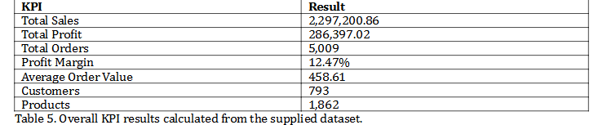
5.2 Model / Method Comparison
The comparison is capability-oriented because the current study does not train predictive models. Static reporting provides basic aggregation but requires repeated manual filtering and comparison. Python descriptive analysis provides reproducible numerical calculations and richer statistical exploration but does not by itself provide a business-user dashboard interface. The proposed workflow combines programmatic validation with a Power BI presentation layer, thereby targeting both analytical reproducibility and interactive exploration.

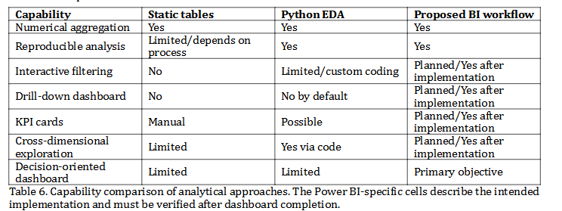

5.3 Data Quality and EDA Analysis
[The supplied file contains zero missing cells and zero exact duplicate rows. Therefore, the principal data-quality result is that the dataset is structurally complete for the fields supplied. Profit is negative in 1,871 rows, positive in 8,058 rows, and exactly zero in 65 rows; negative profit is treated as a business outcome rather than a missing-value error. ]
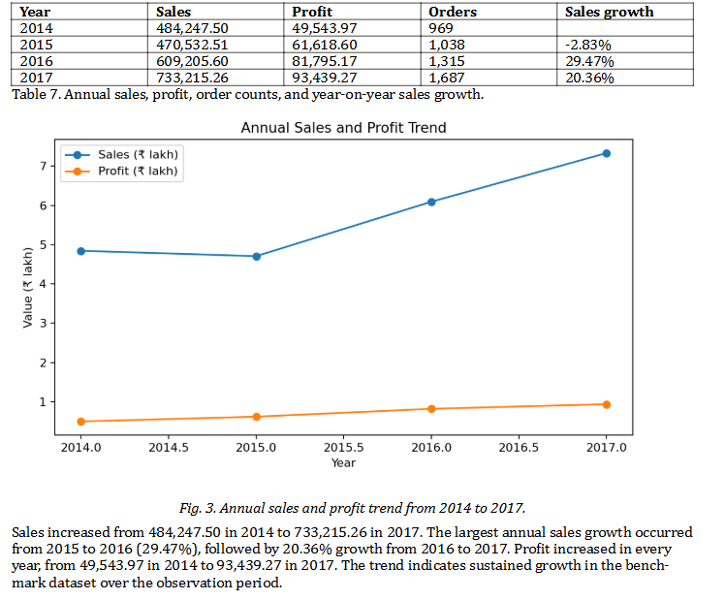
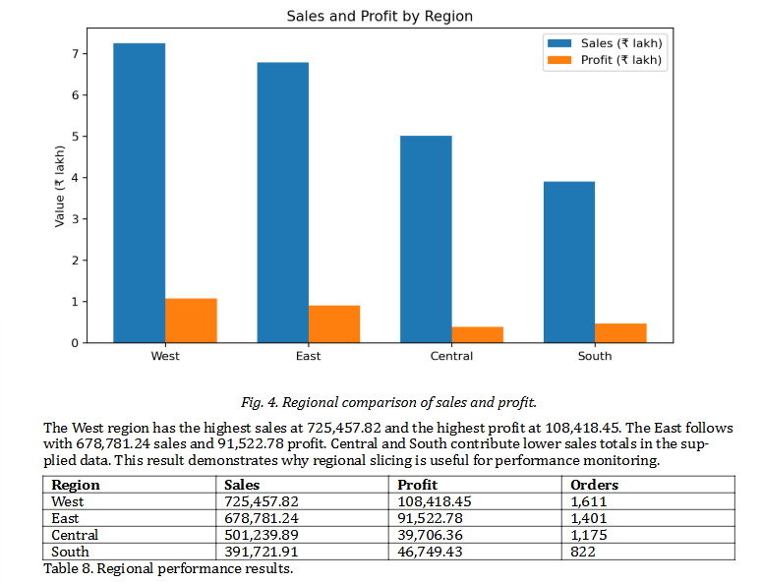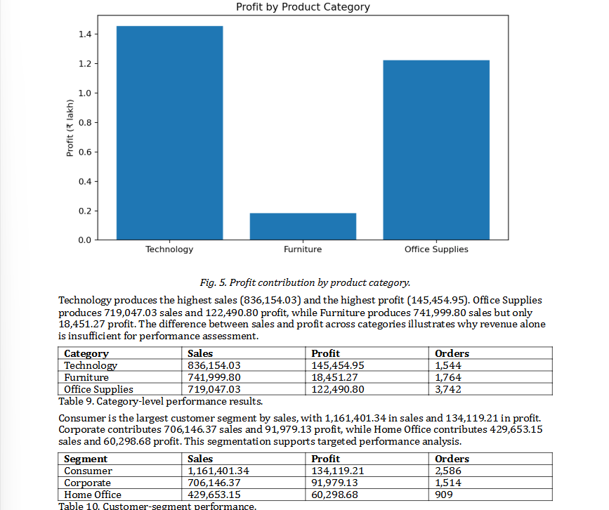
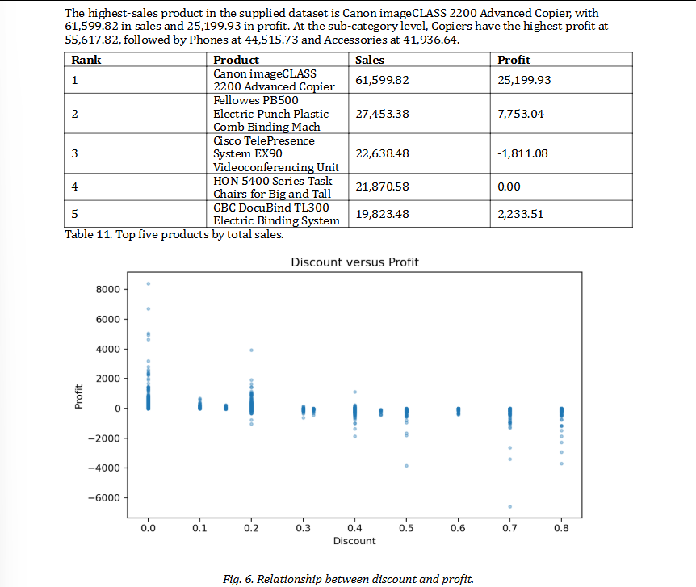
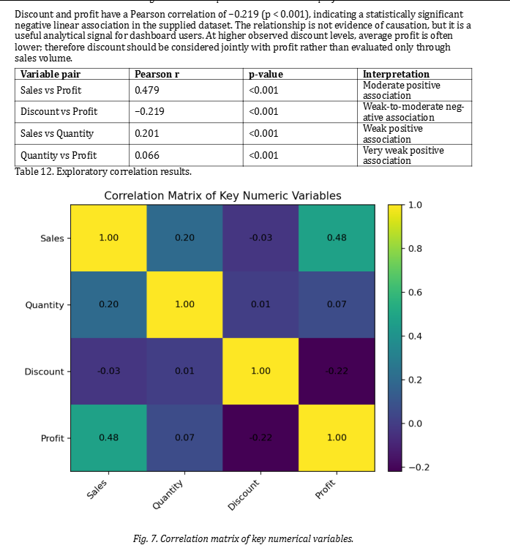
5.4 Additional Result Sub-section: Factor / Business Driver Analysis
[The EDA indicates that organizational performance is multi-dimensional. Sales are moderately associated with profit, while discount has a negative association with profit. Category and region also materially change the aggregate results. These observations support the proposed dashboard design in which users should be able to move from overall KPIs to region, category, segment, product, and time dimensions.
Performance-evaluation note: a formal dashboard response-time experiment and user-usability study have not been conducted yet. Therefore, this draft does not invent latency values, user scores, accuracy percentages, or improvement percentages. Such metrics should be added only after the Power BI dashboard is implemented and tested

6. DISCUSSION
6.1 Interpretation of Findings
[The results show that a single overall sales number does not adequately describe organizational performance. Technology has the largest sales and profit totals, while Furniture has substantial sales but comparatively low profit. Similarly, the West region leads both sales and profit, while the Central and South regions contribute smaller totals. The annual trend shows increasing sales and profit across the observation period. The negative association between discount and profit provides another example of why profitability should be analyzed alongside revenue. ]
6.2 Comparison With Previous Studies
[The findings are consistent with the broader BI literature in emphasizing the importance of data quality, integrated analysis, and decision-oriented information [1], [5], [7], [9]. The visual analytics literature supports the use of interactive views for iterative exploration and details-on-demand [14]–[16]. Unlike organizational survey studies that evaluate BI capabilities at enterprise level [7], [27], the present study demonstrates these principles using a transaction-level sales dataset and explicit KPI calculations.]
6.3 Theoretical Implications
[The study supports the view that BI value depends on the chain connecting data quality, analytical capability, information presentation, and user interpretation. The methodology operationalizes this chain as a reproducible pipeline rather than treating the dashboard as an isolated visualization artifact.]
6.4 Practical Implications
For practitioners, the results indicate that sales, profit, customer, category, regional, and discount dimensions should be examined together. Managers can use the proposed dashboard to identify high-contribution areas, investigate low-profit combinations, monitor temporal trends, and compare customer segments. The proposed architecture is particularly suitable for situations where users need both a high-level overview and drill-down access to transaction dimensions.
6.5 Unexpected Findings
One notable observation is that Furniture records relatively high sales but much lower profit than Technology and Office Supplies. This demonstrates a potential mismatch between revenue contribution and profitability and reinforces the need for multi-KPI analysis. The correlation analysis also shows that Quantity has only a weak relationship with Profit, indicating that selling more units does not automatically imply proportional profitability.
7. LIMITATIONS
- The study uses one benchmark sales dataset; therefore, findings should not be generalized directly to all organizations or industries.
- The supplied dataset represents historical transaction records and does not constitute a real-time operational data stream.
- The present experiment is descriptive and diagnostic rather than predictive; no machine-learning model is claimed as part of the completed analysis.
- The Power BI dashboard screenshots and interface-level usability measurements are pending final dashboard implementation.
- Capability comparisons are structured and evidence-based but are not a randomized user study or a controlled time-on-task experiment.
- Correlation results identify association and should not be interpreted as causal relationships.

8. CONCLUSION AND FUTURE WORK
This paper developed and evaluated a Business Intelligence-oriented framework for organizational performance analysis using the Superstore Sales Dataset. The analysis established a complete dataset profile, verified data completeness and duplicate status, calculated core KPIs, examined regional/category/segment performance, analyzed yearly trends, and evaluated relationships among sales, quantity, discount, and profit. The results demonstrate the usefulness of combining revenue and profitability measures with customer, product, regional, and temporal dimensions. The proposed Power BI layer is intended to convert these analytical results into an interactive decision-support interface.
Future work includes: (1) completing and validating the Power BI dashboard with actual screenshots and interactive controls; (2) conducting a formal usability and response-time evaluation; (3) extending the study with additional datasets for cross-dataset validation; (4) adding forecasting or machine-learning models as a separate predictive module; and (5) exploring automated refresh, anomaly detection, and explainable analytics.
DECLARATIONS
Funding
No external funding was received for this student project.
Conflict of Interest
The authors declare no conflict of interest.
Ethics Statement
The study uses a benchmark business-sales dataset and does not involve human subjects, personal medical information, or experimental intervention. Any redistribution or publication of the dataset should follow the dataset provider's terms.
Data Availability
The analysis in this draft is based on the Superstore Sales Dataset supplied by the project team. The final paper should provide the permitted dataset source or repository link used for submission.
Author Contributions
K. Nishmitha: project coordination, literature review, methodology and documentation. Ammana Aditi Reddy: data analysis, EDA, KPI analysis and dashboard development. Aenugu Prachetha Reddy: system design, visualization support, implementation and documentation. Final responsibilities should be updated if the team division changes.
Acknowledgements
The authors acknowledge their faculty mentor and institution for guidance and support in completing the project.

REFERENCES
[1] S. Negash, “Business Intelligence,” Communications of the Association for Information Systems, vol. 13, 2004, pp. 177–195, doi: 10.17705/1CAIS.01315.
[2] H. J. Watson and B. H. Wixom, “The Current State of Business Intelligence,” Computer, vol. 40, no. 9, 2007, pp. 96–99, doi: 10.1109/MC.2007.331.
[3] Z. Jourdan, R. K. Rainer, and T. E. Marshall, “Business Intelligence: An Analysis of the Literature,” Information Systems Management, vol. 25, no. 2, 2008, pp. 121–131, doi: 10.1080/10580530801941512.
[4] H. Baars and H.-G. Kemper, “Management Support with Structured and Unstructured Data—An Integrated Business Intelligence Framework,” Information Systems Management, vol. 25, no. 2, 2008, pp. 132–148, doi: 10.1080/10580530801941058.
[5] H. Chen, R. H. L. Chiang, and V. C. Storey, “Business Intelligence and Analytics: From Big Data to Big Impact,” MIS Quarterly, vol. 36, no. 4, 2012, pp. 1165–1188, Doi: 10.2307/41703503.
[6] E. P. Lim, H. Chen, and G. Chen, “Business Intelligence and Analytics: Research Directions,” ACM Transactions on Management Information Systems, vol. 3, no. 4, 2013, Art. no. 17, doi: 10.1145/2407741.
[7] Ö. Işık, M. C. Jones, and A. Sidorova, “Business Intelligence Success: The Roles of BI Capabilities and Decision Environments,” Information & Management, vol. 50, no. 1, 2013, pp. 13–23, doi: 10.1016/j.im.2012.12.001.
[8] H. J. Watson and B. H. Wixom, “The BI-Based Organization,” International Journal of Business Intelligence Research, vol. 1, no. 1, 2010, pp. 13–28.
[9] V.-H. Trieu, “Getting Value from Business Intelligence Systems: A Review and Research Agenda,” Decision Support Systems, vol. 93, 2017, pp. 111–124, doi: 10.1016/j.dss.2016.09.019.
[10] B. H. Wixom and H. J. Watson, “An Empirical Investigation of the Factors Affecting Data Warehousing Success,” MIS Quarterly, vol. 25, no. 1, 2001, pp. 17–41.
[11] K. Eberhard, “The Effects of Visualization on Judgment and Decision-Making: A Systematic Literature Review,” Management Review Quarterly, vol. 73, 2023, pp. 167–214, doi: 10.1007/s11301-021-00235-8.
[12] C. Burnay, M. Lega, and S. Bouraga, “Business Intelligence and Cognitive Loads: Proposition of a Dashboard Adoption Model,” Data & Knowledge Engineering, vol. 152, 2024, Art. no. 102310, doi: 10.1016/j.datak.2024.102310.
[13] A. Perdana, A. Robb, and F. Rohde, “Interactive Data and Information Visualization: Unpacking Its Characteristics and Influencing Aspects on Decision-Making,” Journal of Information Systems, 2019.
[14] T. Munzner, “A Nested Model for Visualization Design and Validation,” IEEE Transactions on Visualization and Computer Graphics, vol. 15, no. 6, 2009, pp. 921–928, doi: 10.1109/TVCG.2009.111.
[15] J. Heer and B. Shneiderman, “Interactive Dynamics for Visual Analysis,” Communications of the ACM, vol. 55, no. 4, 2012, pp. 45–54, doi: 10.1145/2133806.2133821.
[16] B. Shneiderman, “The Eyes Have It: A Task by Data Type Taxonomy for Information Visualizations,” in Proc. IEEE Symposium on Visual Languages, 1996, pp. 336–343, doi: 10.1109/VL.1996.545307.
[17] W. S. Cleveland and R. McGill, “Graphical Perception: Theory, Experimentation, and Application to the Development of Graphical Methods,” Journal of the American Statistical Association, vol. 79, no. 387, 1984, pp. 531–554, doi: 10.1080/01621459.1984.10478080.
[18] E. R. de Almeida Valiati, M. S. Pimenta, and C. M. D. S. Freitas, “A Taxonomy of Tasks for Guiding the Evaluation of Multidimensional Visualizations,” in Proc. BELIV, 2006, doi: 10.1145/1168149.1168169.
[19] H. Shen, T. Bednarz, H. Nguyen, F. Feng, T. Wyeld, P. J. Hoek, and E. H. S. Lo, “Information Visualisation Methods and Techniques: State-of-the-Art and Future Directions,” Journal of Information and Intelligence, vol. 16, 2019, Art. no. 100102, doi: 10.1016/j.jii.2019.07.003.
[20] J. J. Thomas and K. A. Cook, “A Visual Analytics Agenda,” IEEE Computer Graphics and Applications, vol. 26, no. 1, 2006, pp. 10–13, doi: 10.1109/MCG.2006.5.
[21] D. A. Keim, “Information Visualization and Visual Data Mining,” IEEE Transactions on Visualization and Computer Graphics, vol. 8, no. 1, 2002, pp. 1–8.
[22] S. K. Card, J. D. Mackinlay, and B. Shneiderman, Eds., Readings in Information Visualization: Using Vision to Think. San Francisco, CA, USA: Morgan Kaufmann, 1999.
[23] S. Few, Information Dashboard Design: The Effective Visual Communication of Data. Sebastopol, CA, USA: O’Reilly Media, 2006.
[24] T. H. Davenport and J. G. Harris, Competing on Analytics: The New Science of Winning. Boston, MA, USA: Harvard Business School Press, 2007.
[25] S. Rouhani, S. Asgari, and S. V. Mirhosseini, “Review Study: Business Intelligence Concepts and Approaches,” American Journal of Scientific Research, no. 50, 2012, pp. 62–75.
[26] H. Kefi and N. Koppel, “Measuring Data Warehousing Success: An Empirical Investigation Applying the DeLone and McLean Model,” International Journal of Data Analysis Techniques and Strategies, vol. 3, no. 2, 2011, pp. 178–201, doi: 10.1504/IJDATS.2011.039850.
[27] S. F. Wamba, A. Gunasekaran, S. Akter, S. J.-F. Ren, R. Dubey, and S. J. Childe, “Big Data Analytics and Firm Performance: Effects of Dynamic Capabilities,” Journal of Business Research, vol. 70, 2017, pp. 356–365, doi: 10.1016/j.jbusres.2016.08.009.
[28] P. Mikalef, M. Boura, G. Lekakos, and J. Krogstie, “Big Data Analytics Capabilities and Innovation: The Mediating Role of Dynamic Capabilities and Moderating Effect of the Environment,” British Journal of Management, vol. 30, no. 2, 2019, pp. 272–298.
[29] P. Mikalef, M. Boura, G. Lekakos, and J. Krogstie, “Big Data Analytics and Firm Performance: Findings from a Mixed-Method Approach,” Journal of Business Research, vol. 98, 2019, pp. 261–276, doi: 10.1016/j.jbusres.2019.01.044.
[30] A. Grover, A. Chiang, M. Liang, and D. Zhang, “Creating Strategic Business Value from Big Data Analytics: A Research Framework,” Journal of Management Information Systems, vol. 35, no. 2, 2018, pp. 388–423.
[31] A. Gandomi and M. Haider, “Beyond the Hype: Big Data Concepts, Methods, and Analytics,” International Journal of Information Management, vol. 35, no. 2, 2015, pp. 137–144, doi: 10.1016/j.ijinfomgt.2014.10.007.
[32] F. Provost and T. Fawcett, Data Science for Business: What You Need to Know about Data Mining and Data-Analytic Thinking. Sebastopol, CA, USA: O’Reilly Media, 2013

